Article Title (The title should be a declarative phrase without punctuation at the end and at least 7 words but no more than 25 words)
Firstname Lastname¹, Firstname Lastname², Firstname Lastname^{2, *}
¹Department, Institution, City, Country
²Department, Institution, City, Country
Email address:
email1@authorname.com (Author Name1), email2@authorname.com (Author Name2), email3@authorname.com (Author Name3)
*Corresponding author
ORCID:
ORCID1 (Author Name1), ORCID2 (Author Name2), ORCID3 (Author Name3)
Note: (Please remove this note once you have completed this section.)
1. The full name of the author(s) should be provided without abbreviations.
2. There should be no job titles or degree before the author's name.
3. At least one corresponding author must be designated and an active email address should be provided accordingly.
4. Authors are recommended to provide the 16-digit ORCID.
To cite this article:
Author's Name. (Year). Article Title. Journal Title, Volume(Issue), Page Range. DOI.
Received: MM DD, 2023; Accepted: MM DD, 2023; Published: MM DD, 2023

Abstract: The abstract should be a concise single paragraph, ranging from 200 to 400 words, and should not include any reference citations or footnotes. For research articles, it should provide a brief overview of the background, objective, method, result and conclusion of your article before the main body. In case report, abstract should include background, case presentation and conclusion. It is important to ensure that the abstract presents an objective representation of the article, avoiding the inclusion of results that are not substantiated in the main text and refraining from exaggerating the main conclusions.
Keywords: Keyword1, Keyword2 … Keyword8 (Please provide 3-8 relevant keywords that are specific to the article and commonly used within the subject discipline.)

1. Introduction
The introduction plays an important role in providing background information (including relevant references), emphasizing the importance of the study, and outlining its objectives. It is crucial to conduct a thorough review of the current state of the research field and incorporate key publications into your work. By referencing other research papers, you can provide context and position your own work within the broader research landscape. The final paragraph should provide a concise summary of the main findings and conclusions, which will be helpful to the readers.
References will be consecutively numbered as they appear in the text by using numerals in square brackets (e.g., [1], [2, 3] or [4–7]). Further details on references can be found at the end of this document.
2. Manuscript Formatting
The article should be written in English. An article should be between 6 and 25 pages, and exceed 2000 words. For original research articles, it should include the headings Introduction, Materials and Methods, Results, Discussion and Conclusions. Other types of articles can be written with a more flexible structure.
2.1. Headings
The headings or subheadings should be numbered in order as the given style. Each headings or subheadings should not exceed 3 lines. There should be at least 2 subheadings but no more than 10 subheadings under one heading.
(Main Text Paragraphs)
2.1.1. Sample Heading Level 3 (Optional)
(Main Text Paragraphs)
2.1.2. Sample Heading Level 3 (Optional)
(Main Text Paragraphs)
2.2. Equations
Please use either the Microsoft Equation Editor or the MathType add-on when including equations. It is essential that equations are editable and not presented in a picture format. All equations should be consecutively numbered using Arabic numerals within parentheses, such as (1), (2), (3)...
X+Y=Z (1)
X²-Y²=R* (2)
2.3. Figures
Each figure should have a concise caption describing what it represents. Figure captions should be presented below the figures, not in the figure file. Figures must be consecutively numbered using Arabic numerals, such as Figure 1, Figure 2, Figure 3...
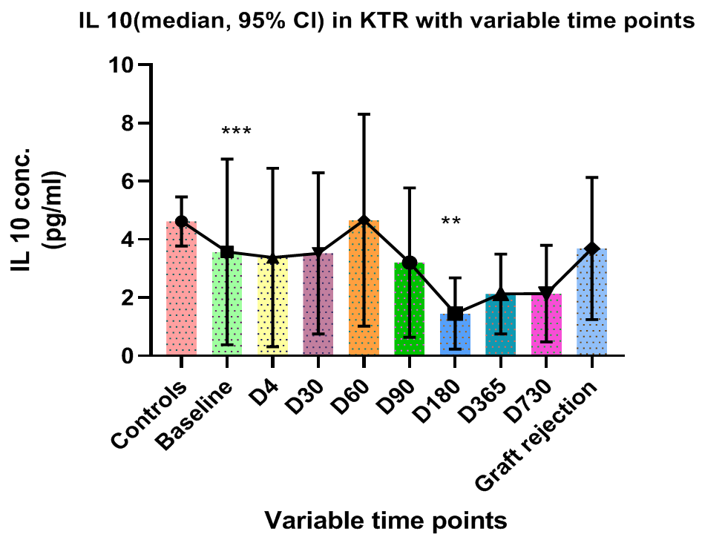
Figure 1. Figure caption.
2.4. Tables
Each table should have a concise caption describing what it represents. Table captions should be presented above the tables. All tables should be editable with no image format. Vertical lines should not be used to separate columns. The corresponding meaning of the symbol in the table should be given below the table. Tables must be consecutively numbered using Arabic numerals, such as Table 1, Table 2, Table 3...
Table 1. Table caption.
Column1 | Column2
Row1* | Row1
Row2 | Row2
Row3 | Row3
Row4 | Row4
Row5 | Row5
Row6 | Row6
Row7 | Row7
*Table Footnote.
2.5. Schemes
Schemes follow the same formatting as Figures.
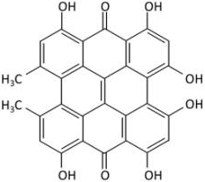
Scheme 1. Scheme caption.
3. Materials and Methods
The Materials and Methods section should provide comprehensive details to enable other researchers to replicate the study and further expand upon the published results. If you have multiple methods, consider using subsections with appropriate headings to enhance clarity and organization.
4. Results
The results section should provide an accurate and concise description of the experimental findings, and the resulting conclusions that can be inferred from the experiments. Meanwhile, the results should be presented in a transparent and truthful manner, avoiding any fabrication or improper manipulation of data. Where applicable, results of statistical analysis should be included in the text or as tables and figures.
5. Discussion
In this section, authors are advised to provide a thorough analysis of the results and make comparisons with relevant literature, not a short summary or conclusion. Any future research directions could also be stated in the discussion.
6. Conclusions
The conclusion section should precisely articulate the main findings of the article, emphasizing its significance and relevance. In the conclusion, it is highly recommended that authors avoid referencing figures or tables. Instead, these should be appropriately referenced within the body of the paper.
Funding (Optional)
Authors are required to disclose all sources of research funding, including grants supporting the work and any received funds covering publication costs.
Acknowledgments (Optional)
This section serves to recognize contributions that do not meet authorship criteria, including technical assistance, donations, or organizational aid. Individuals or organizations should be acknowledged with their full names. The acknowledgments should be placed after the conclusion and before the references section in the manuscript.
Conflicts of Interest
Authors are required to disclose any financial, commercial, or other affiliations that could be perceived as potential conflicts of interest by the academic community. In the absence of such relationships, authors will be requested to confirm the following statement:
“The authors declare no conflicts of interest.”

References
It is the author's responsibility to ensure the completeness and accuracy of the information in each reference. All references must be numbered in the order of their first citation in the text and listed individually at the end of the manuscript. Please include the digital object identifier (DOI) for all references, if available.
In-text citations should be identified by numbers in square brackets [], placed before the punctuation. Each reference should be cited within the text, and any references that are not cited will be excluded from the list.
SciencePG citation rule Example:
Single citation: [1]
Multiple citations: [2–6, 10]
Use en dashes to join the first and last numbers of a closed series: [2-6]
Use commas to separate other parts of multiple citations: [2-6, 8]
Note: The numbers in square brackets correspond to the order of the references in the reference list.
- Author 1, Author 2, Author 3. Article Title. Journal Title. Year, Volume(Issue), Page Range. DOI or URL. (Journal Articles)
Example:
Gerold, E., Antrekowitsch, H. A Sustainable Approach for the Recovery of Manganese from Spent Lithium-Ion Batteries via Photocatalytic Oxidation, International Journal of Materials Science and Applications. 2022, 11(3), 66-75. doi: 10.11648/j.ijmsa.20221103.12.
- Author 1, Author 2, Author 3. Book Title. Edition. Publisher Location: Publisher; Year, Page Range. (Books)
Example:
Cozby, P. C., Bates, S. C. Methods in behavioral research. New York, NY: McGraw Hill; 2012, pp. 14–16.
- Author 1, Author 2. Title of the chapter. In Book Title, Edition. Publisher Location: Publisher; Year, Page Range. (Book Chapters)
Example:
Rychtarova, J., Krupova, Z., Brzakova, M., Borkova, M., Elich, O., Dragounova, H., Seydlova, R., and Sztankoova, Z. Milk quality, somatic cell count, and economics of dairy goat’s farm in the Czech Republic. In Goat Science-Environment, Health and Economy, Kukovics, S., Ed., Intech Open: London, UK; 2021, pp. 14–16.
- Author 1, Author 2, Author 3. Title of Presentation. In Proceedings of the Name of the Conference, Location of Conference, Country, Year of Conference; Page number (optional). (Conference Proceedings)
Example:
Smith, J., Johnson, A., Brown, K. A Deep Learning Approach for Sentiment Analysis in Social Media. In Proceedings of the 2019 International Conference on Data Science, New York, USA, 2015; pp. 4489–4497.
- Author 1. Title of Thesis. Level of Thesis, Degree-Granting University, Location of University, Date of Completion. (Thesis)
Example:
Miranda, C. Exploring the Lived Experiences of Foster Youth Who Obtained Graduate Level Degrees: Self-efficacy, Resilience, and the Impact on Identity Development. Ph.D. Thesis, Pepperdine University, 2019.
- Publishing body. Title. [Internet]. Available from: URL. [Accessed Day Month Year]. (Websites)
Example:
National Library of Medicine, “Dinitrogen Tetroxide”. Available from: https://pubchem.ncbi.nlm.nih.gov/. [Accessed 6 October 2022].

